Apurba Jachai - User Manual
National ID Extraction - sign in, upload an NID scan, and get back its fields as editable, copyable text

Test Credentials

URL | Email | Password
https://jachai.apurbatech.io/ | research@apurbatech.com | NIDAI@apurba

1. Sign in
Open the app and enter your account email and password, then select Sign in. A session lasts about an hour.
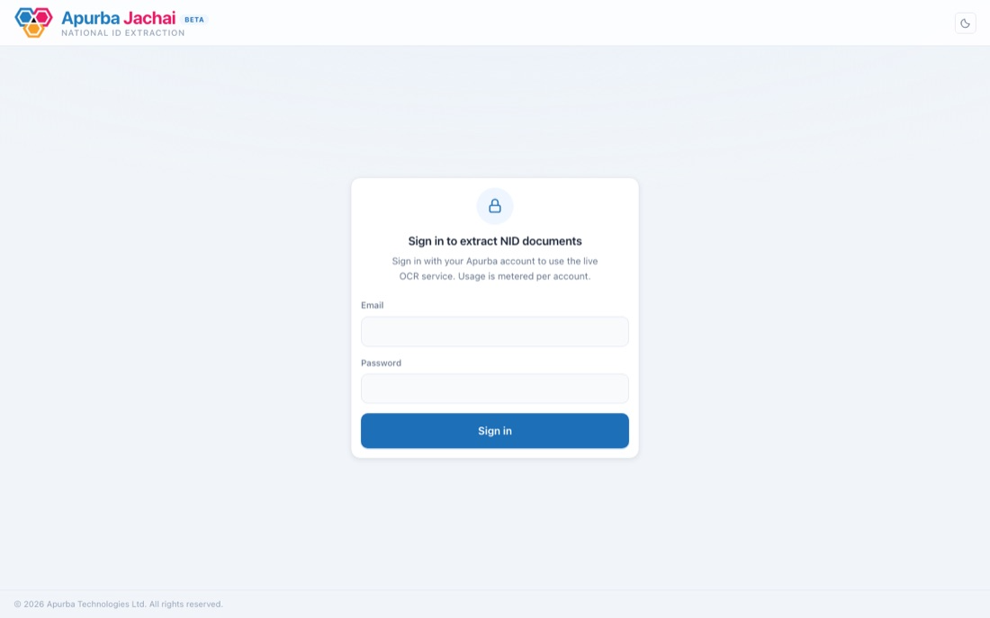

2. Upload a document
Drag a scan onto the upload area, or click browse your files to pick one. Accepted formats: .jpg, .jpeg, .png, .pdf, up to 25 MB.
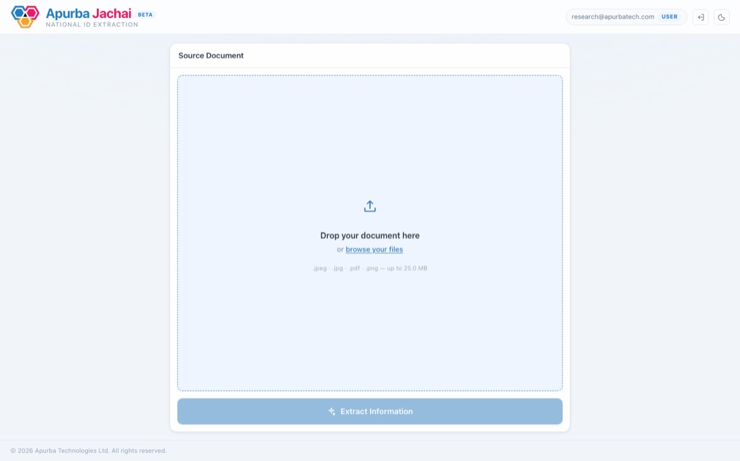
The file loads into a preview so you can check it before extracting.
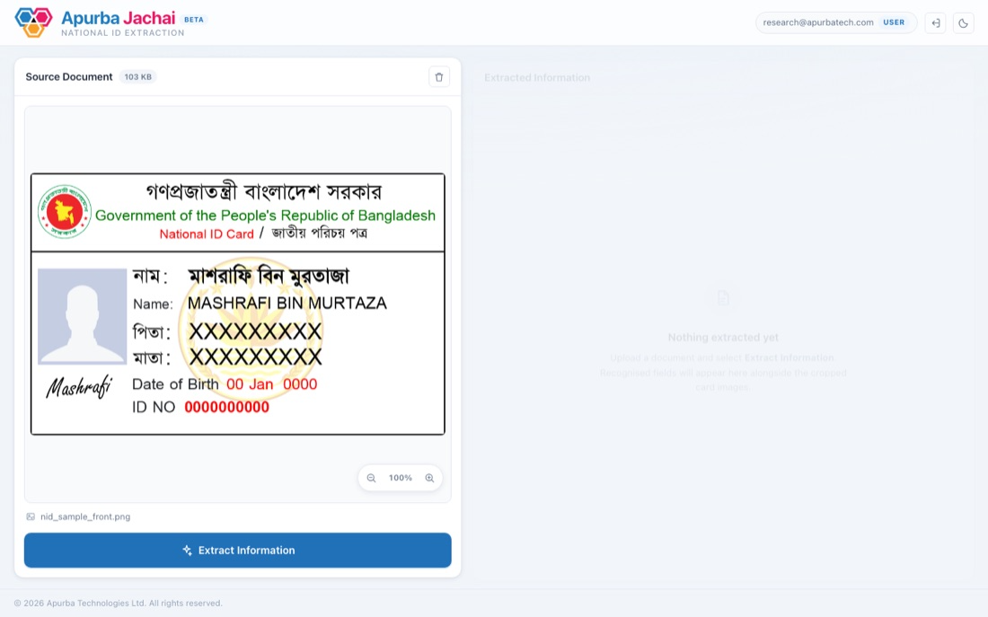

3. Extract information
Select Extract Information (or press Ctrl/Cmd + Enter). The panel shows a short loading state while the document is read.
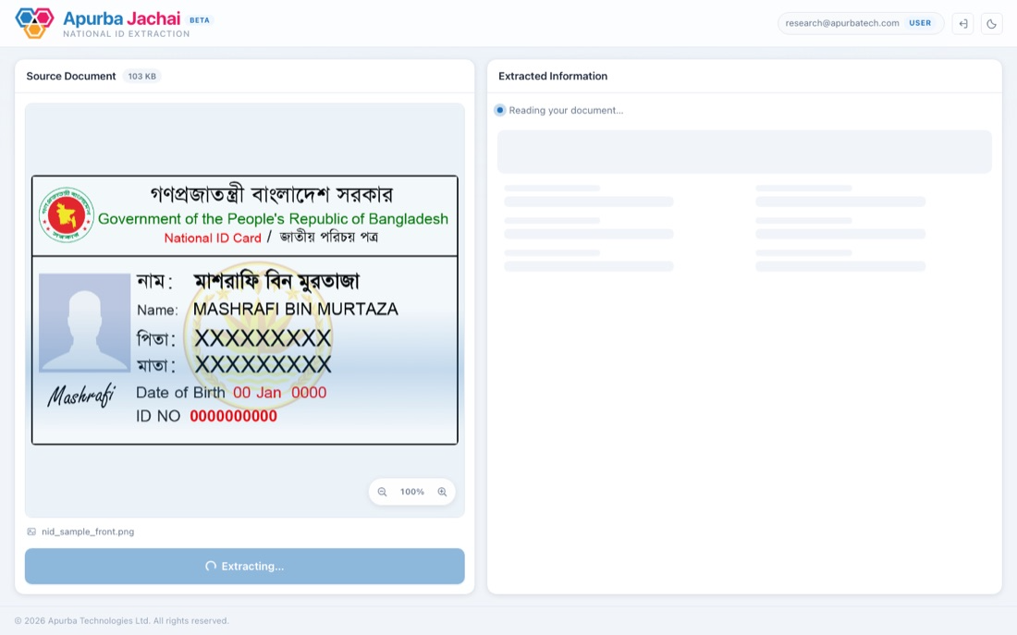

4. Review the results
The extracted fields appear on the right: photo and signature at the top, NID number and date of birth in their own card, then the remaining fields with Bangla and English side by side.
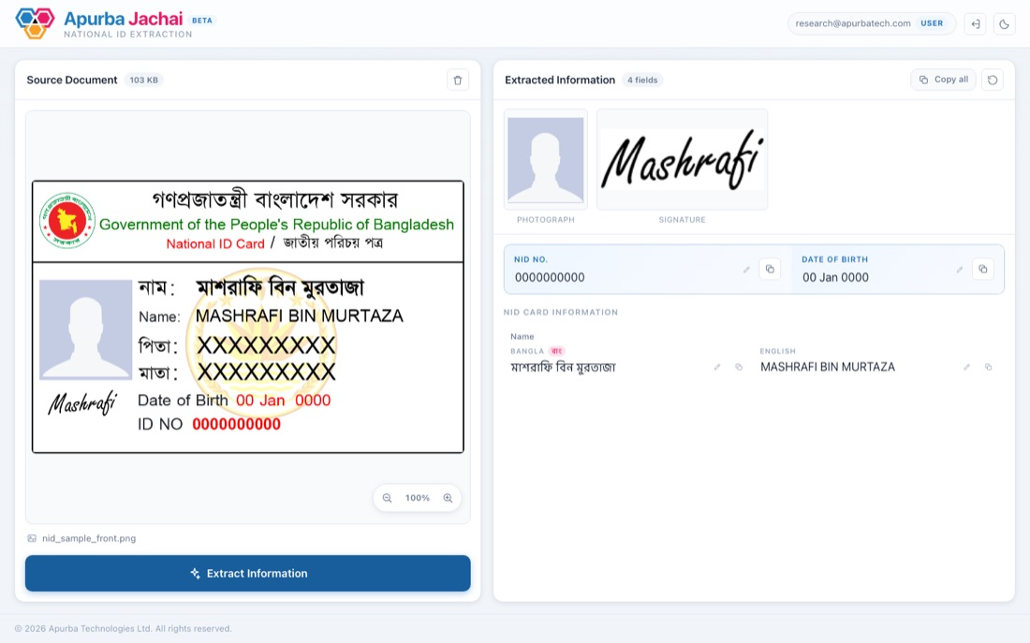
To fix a misread value, click into the field and edit it directly - the correction replaces the display value but the original is kept, so it can be undone.

5. Edit a field
Click directly into any field to correct a misread value - it becomes an editable box in place, and the field is marked as edited. Press Escape to undo just that correction, or use the "N edited" button in the panel header to restore every field at once.
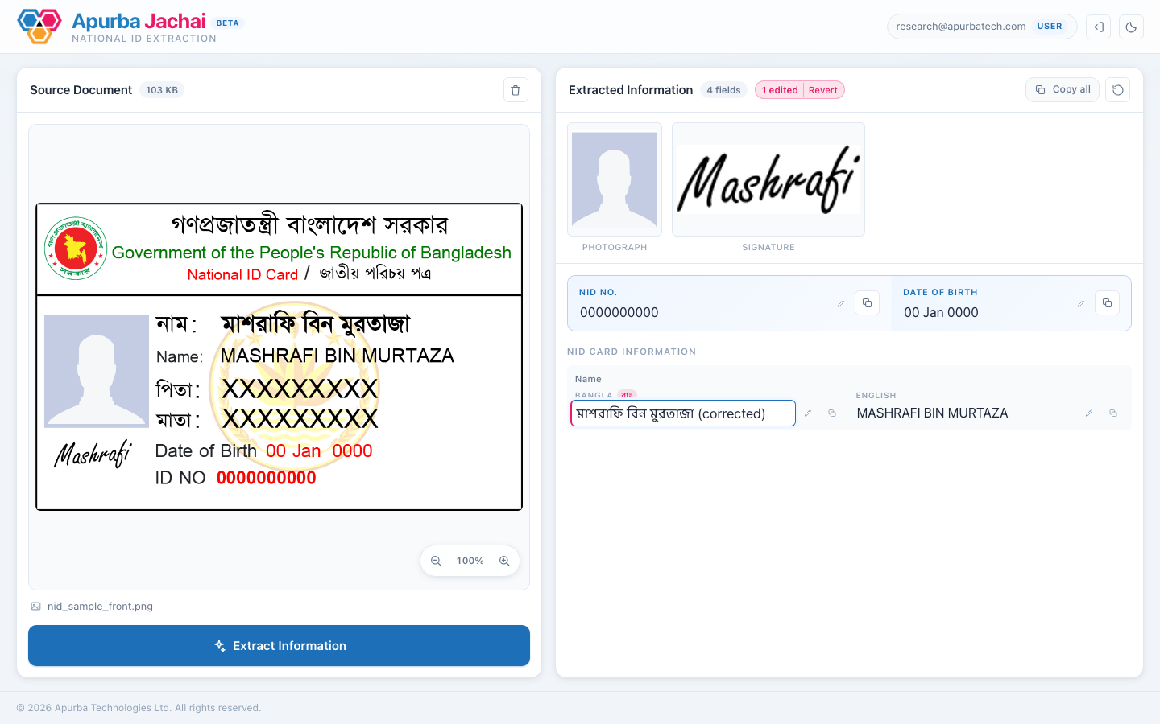
The photo, signature, and card images stay pinned above the field list as a live snapshot of the source document, so a correction can be checked against it without scrolling away.

6. Copy the data
Each field has its own copy button, or use Copy all in the results header to copy the whole record at once. A checkmark confirms the copy.
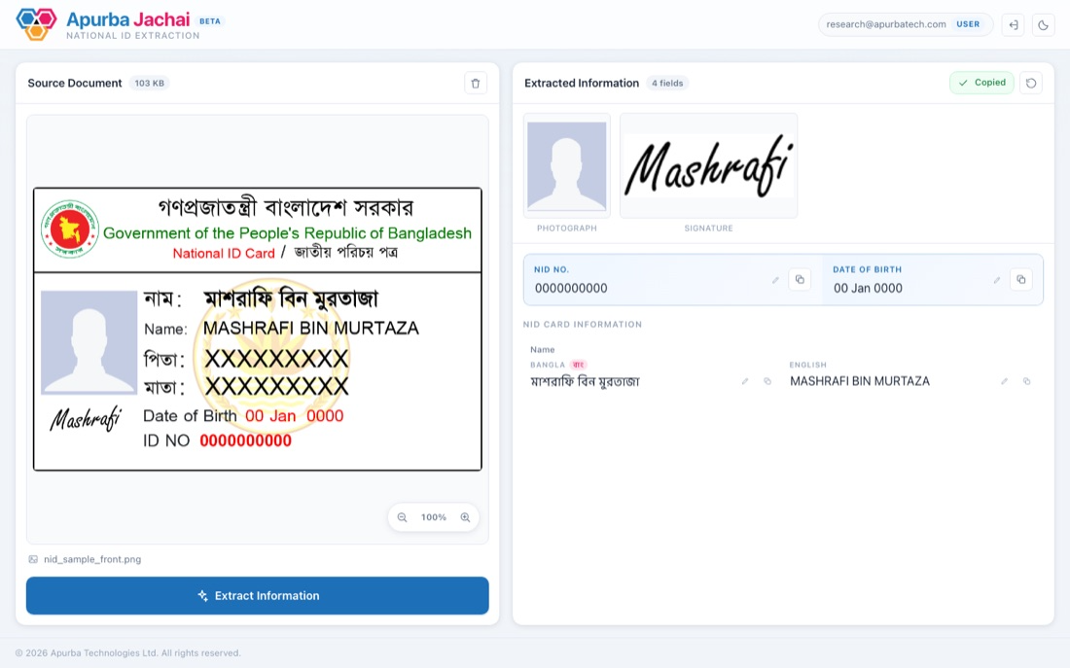

7. Sign out
Select the sign-out icon next to your email in the header when you're done. This ends the session and returns you to the sign-in screen.

Troubleshooting
Message | Meaning
Unsupported file type / File is too large | The file isn't a JPEG/PNG/PDF, or exceeds 25 MB.
Usage limit reached | Your account's extraction quota is used up.
Your session has expired | Sign in again - your work in progress is not saved.
Extraction failed / No fields recognised | The scan couldn't be read; try a clearer, upright image.

